

SIMATS ENGINEERING

Saveetha Institute of Medical and Technical Sciences
Chennai- 602105

Student Name: S . Siva Sai Reddy Reg. No:192424309
Course Code: DSA0216 Slot: B
Course Name: Computer Vision with OpenCV for Modern AI
Course Faculty: Dr. Senthilvadivu S, Dr. Kumaragurubaran T
Project Title: Augmented Reality System for Architectural Visualization

Module Photographs: (3 photographs –Module Photo, Individual student contribution module work in the project and presentation image)
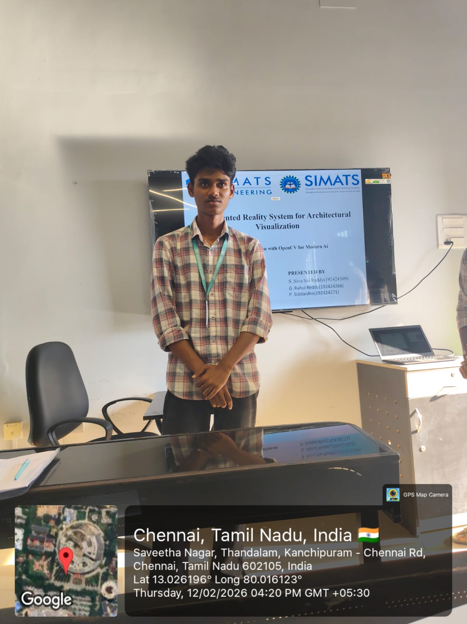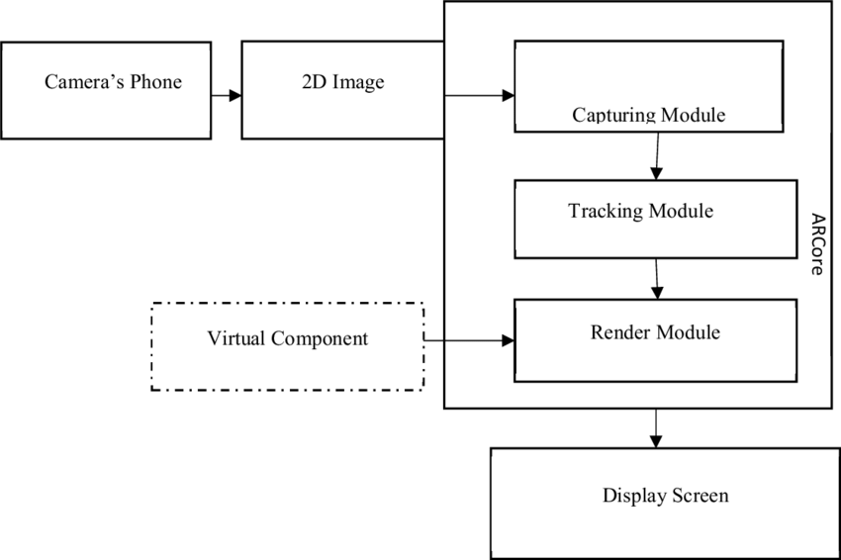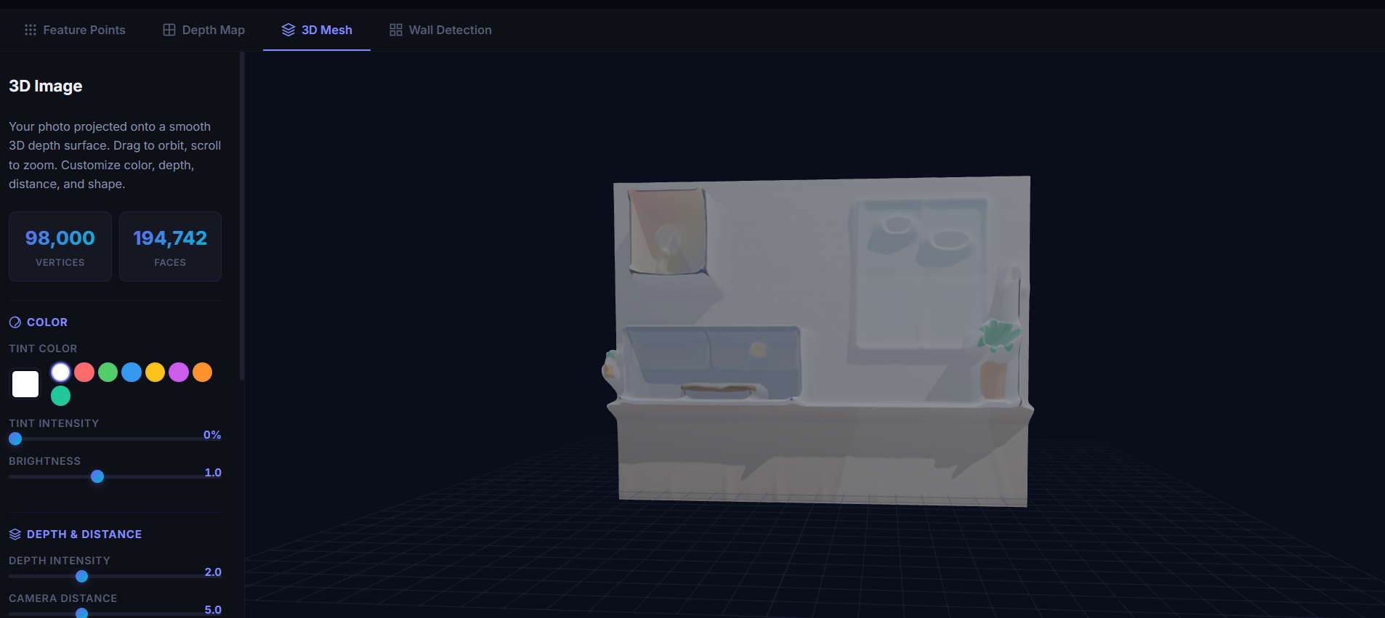
Project Description: (here you write what you did in this project (contribution) including Model Description
The system enables touch-based and gesture-based interactions using AR development platforms such as Unity integrated with AR SDKs like ARCore or ARKit. Users can place models on detected surfaces, reposition them using drag gestures, scale them with pinch gestures, and rotate them through multi-touch inputs. The system ensures gesture recognition response time within 200 milliseconds to maintain fluid interaction. Key AR visualization controls include model anchoring, floor toggling, sectional views, material switching, and lighting adjustments. Users can enable or disable layers (walls, furniture, structural elements), change textures in real time, and switch between exterior and interior walkthrough modes.

Student Signature Guide Signature

